Final VAPT Report Template



PREPARED BY: <name of the pentester or company name>
Submitted To: <name of the client>
Submission Date: <date>

TABLE OF CONTENTS
EXECUTIVE SUMMARY 2
HIGH LEVEL ASSESSMENT OVERVIEW 3
Observed Security Strengths 4
Areas for Improvement 4
Short Term Recommendations 4
Long Term Recommendations 4
SCOPE 4
Project Scope 5
Network Information 5
TESTING METHODOLOGY 5
CLASSIFICATION DEFINITIONS 6
Risk Classifications 7
Exploitation Likelihood Classifications 7
Business Impact Classifications 7
Remediation Difficulty Classifications 8
ASSESSMENT FINDINGS 8
FORENSIC EVIDENCE COLLECTION AND ANALYSIS 10
APPENDIX A - TOOLS USED 11
APPENDIX B - ENGAGEMENT INFORMATION 12
Client Information 12
Version Information 12
Contact Information 13

EXECUTIVE SUMMARY
<TEAM NAME> performed a security assessment of the internal corporate network of <CLIENT NAME> on <TEST DATE>. <TEAM NAME>’s penetration test simulated an attack from an external threat actor attempting to gain access to systems within the <CLIENT NAME> corporate network. The purpose of this assessment was to discover and identify vulnerabilities in <CLIENT NAME>’s infrastructure and suggest methods to remediate the vulnerabilities. <TEAM NAME> identified a total of <VULN TOTAL NUM> vulnerabilities within the scope of the engagement which are broken down by severity in the table below.

CRITICAL | HIGH | MEDIUM | LOW
1 | 2 | 2 | 1

The highest severity vulnerabilities give potential attackers the opportunity to <BAD ACTIONS THAT COULD OCCUR HERE - FULL PARAGRAPH WITH HIGH-LEVEL DETAIL>. In order to ensure data confidentiality, integrity, and availability, security remediations should be implemented as described in the security assessment findings.

Note that this assessment may not disclose all vulnerabilities that are present on the systems within the scope. Any changes made to the environment during the period of testing may affect the results of the assessment.

HIGH LEVEL ASSESSMENT OVERVIEW

Observed Security Strengths
<TEAM NAME> identified the following strengths in <CLIENT NAME>’s network which greatly increases the security of the network. <CLIENT NAME> should continue to monitor these controls to ensure they remain effective.
<Strength Category>
- Here list out the all strength of the network that you have identified

Areas for Improvement
<TEAM NAME> recommends <CLIENT NAME> takes the following actions to improve the security of the network. Implementing these recommendations will reduce the likelihood that an attacker will be able to successfully attack <CLIENT NAME>’s information systems and/or reduce the impact of a successful attack.

Short Term Recommendations
<TEAM NAME> recommends <CLIENT NAME> take the following actions as soon as possible to minimize business risk.
<Recommendation Category>
- <Individual Recommendation>

Long Term Recommendations
<TEAM NAME> recommends the following actions be taken over the next <NUM> months to fix hard-to-remediate issues that do not pose an urgent risk to the business.

SCOPE

Project Scope
All testing was based on the scope as defined in the Request for Proposal (RFP) and official written communications. The items in scope are listed below.
- Web Server
- Database Server
- Centralized Directory
- Or Campus Network (LAN)

Network Information
Network | Note
10.0.1.0/24 | SysInfo LLC, San Jose HQ
192.168.137.0/24 | ABC Corporation, Atlanta HQ

TESTING METHODOLOGY
<TEAM NAME GOES HERE>’s testing methodology was split into three phases: Reconnaissance, Target Assessment, and Execution of Vulnerabilities. During reconnaissance, we gathered information about <CLIENT NAME>’s network systems. <TEAM NAME GOES HERE> used port scanning and other enumeration methods to refine target information and assess target values. Next, we conducted our targeted assessment. <TEAM NAME GOES HERE> simulated an attacker exploiting vulnerabilities in the <CLIENT NAME> network. <TEAM NAME GOES HERE> gathered evidence of vulnerabilities during this phase of the engagement while conducting the simulation in a manner that would not disrupt normal business operations.

The following image is a graphical representation of this methodology.

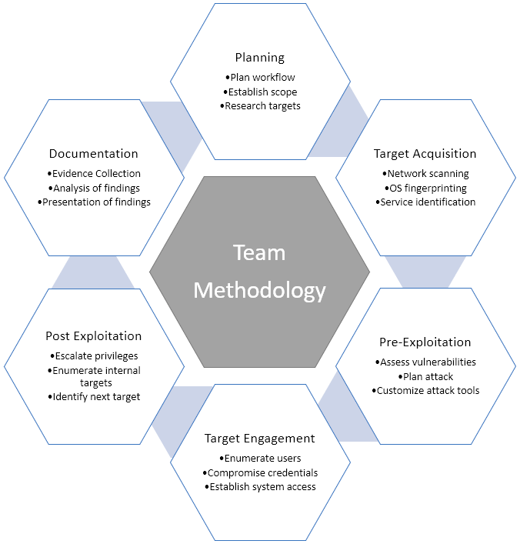

CLASSIFICATION DEFINITIONS

Risk Classifications
Level | Score | Description
Critical | 10 | The vulnerability poses an immediate threat to the organization. Successful exploitation may permanently affect the organization. Remediation should be immediately performed.
High | 7-9 | The vulnerability poses an urgent threat to the organization, and remediation should be prioritized.
Medium | 4-6 | Successful exploitation is possible and may result in notable disruption of business functionality. This vulnerability should be remediated when feasible.
Low | 1-3 | The vulnerability poses a negligible/minimal threat to the organization. The presence of this vulnerability should be noted and remediated if possible.
Informational | 0 | These findings have no clear threat to the organization, but may cause business processes to function differently than desired or reveal sensitive information about the company.

Exploitation Likelihood Classifications
Likelihood | Description
Likely | Exploitation methods are well-known and can be performed using publicly available tools. Low-skilled attackers and automated tools could successfully exploit the vulnerability with minimal difficulty.
Possible | Exploitation methods are well-known, may be performed using public tools, but require configuration. Understanding of the underlying system is required for successful exploitation.
Unlikely | Exploitation requires deep understanding of the underlying systems or advanced technical skills. Precise conditions may be required for successful exploitation.

Business Impact Classifications
Impact | Description
Major | Successful exploitation may result in large disruptions of critical business functions across the organization and significant financial damage.
Moderate | Successful exploitation may cause significant disruptions to non-critical business functions.
Minor | Successful exploitation may affect few users, without causing much disruption to routine business functions.

Remediation Difficulty Classifications
Difficulty | Description
Hard | Remediation may require extensive reconfiguration of underlying systems that is time consuming. Remediation may require disruption of normal business functions.
Moderate | Remediation may require minor reconfigurations or additions that may be time-intensive or expensive.
Easy | Remediation can be accomplished in a short amount of time, with little difficulty.

ASSESSMENT FINDINGS
Number | Finding | Risk Score | Risk
1 | Example Vulnerability Finding | 9 | High
2 | Firewall Rule Set Not Best Practice | 8 | High
3 | Outdated Software | 6 | Medium
4 | Multiple XYZ Vulnerabilities | 5 | Medium
5 | Fake Finding | 2 | Low
TEMPLATE NOTE: (Sorting by descending risk score)

1 - Example Vulnerability Finding
HIGH RISK (8/10)
Exploitation Likelihood | Possible
Business Impact | Severe
Remediation Difficulty | Easy

Synopsis
This is where you give a 1-2 sentence description about the major impact of the finding. This finding is very important because it can destroy the entire business if left unchecked.

Analysis
Longer discussion of the finding. Includes screenshots.
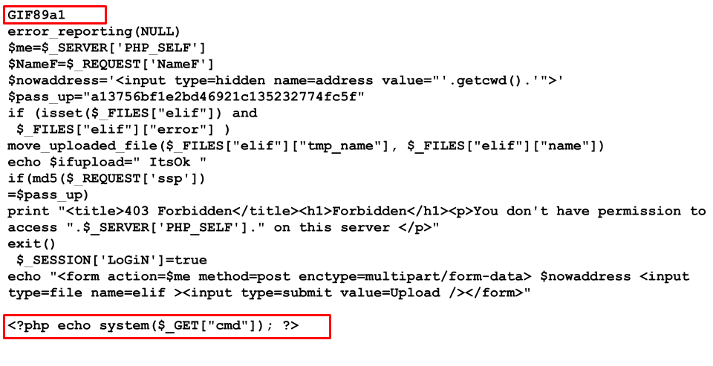
Figure 2.3.1: A php webshell uploaded to XYZ Application

SUGGESTED REMEDIATION

Recommendations

- Remove XYZ to make things more secure
- If you cannot remove XYZ do this…

FORENSIC EVIDENCE COLLECTION AND ANALYSIS

Scope
< Describe the objective of the forensic analysis task.>

Obtain and Verify Forensic Image Test File
< Provide steps for obtaining and extracting test files.>

Create and Import Forensic Image into Autopsy:
<Outline steps for creating and importing forensic images.>

Analyze Forensic Image
<Describe how forensic images were analyzed.>

Export Evidence Files
<Provide details on exporting evidence files and provide the screenshots of your findings.>

APPENDIX A - TOOLS USED

TOOL | DESCRIPTION
BurpSuite Community Edition | Used for testing of web applications.
Metasploit | Used for exploitation of vulnerable services and vulnerability scanning.
Nmap | Used for scanning ports on hosts.
OpenVAS | Used to scan the networks for vulnerabilities.
PostgreSQL Client Tools | Used to connect to the PostgreSQL server.
Table A.1: Tools used during assessment

APPENDIX B - ENGAGEMENT INFORMATION

Client Information
Client | <CLIENT NAME>
Primary Contact | <Person Name>,  <Person’s Title>
Approvers | The following people are authorized to change the scope of engagement and modify the terms of the engagement  - <PERSON NAME 1>  - <PERSON NAME 2>

Version Information
Version | Date | Description
1.0 | <DATE HERE> | Initial report to client

Contact Information
Name | <TEAM NAME> Consulting
Address | 1001 Fake Street, Gotham, NY 11201
Phone | 555-185-1782
Email | <REPLACE WITH PROVIDED EMAIL>

